Introduction to JavaScript

Old versions:

* LiveScript
* JScript
* Standardized JavaScript version is **ECMAScript** <https://en.wikipedia.org/wiki/Ecma_International>

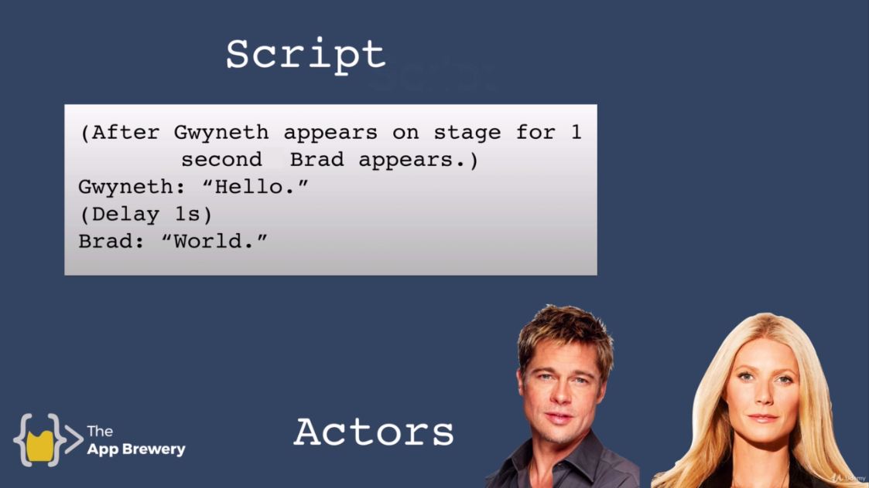

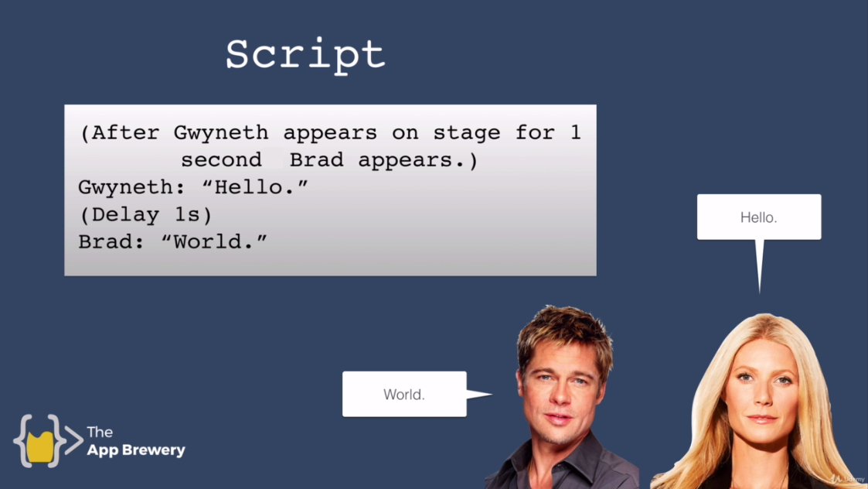

In JavaScript script is JavaScript and actors are elements (headings, paragraphs).

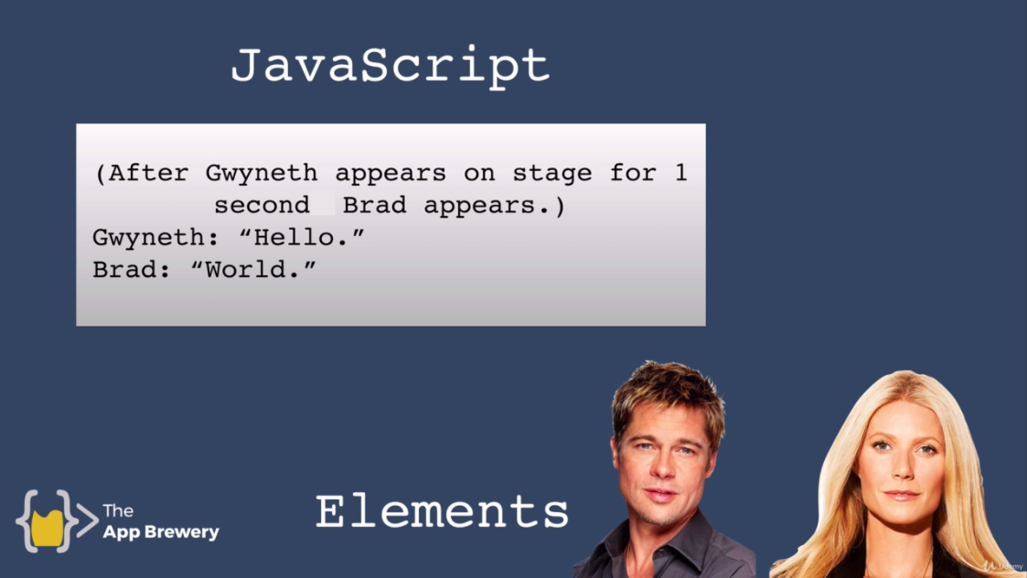

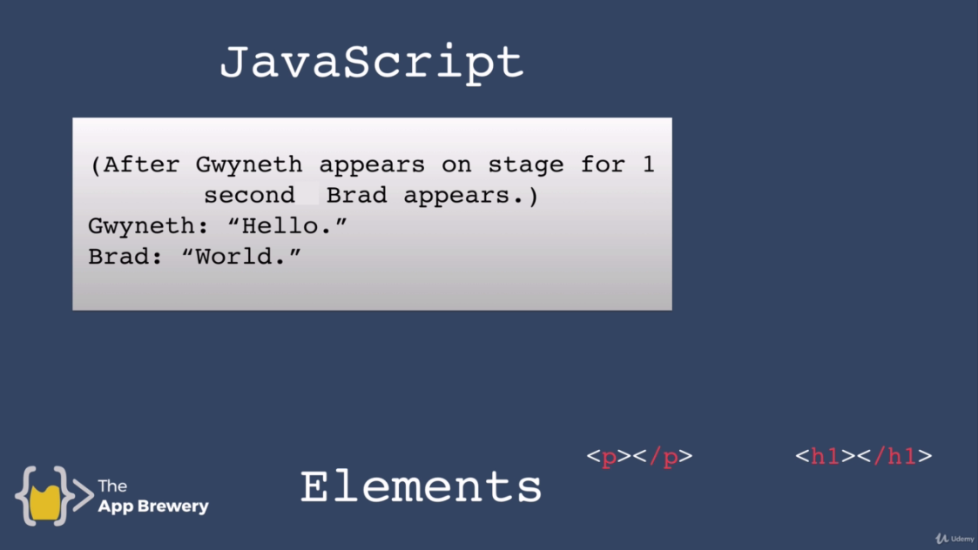

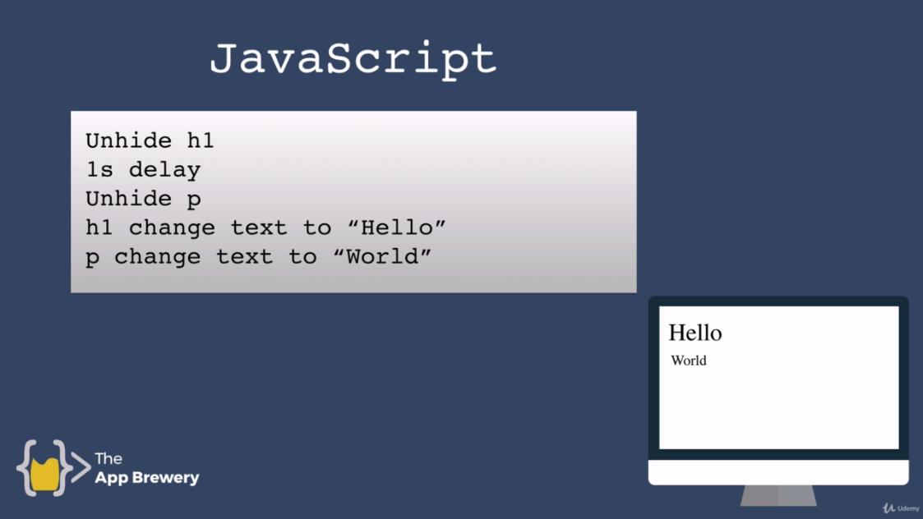

Is Java and JavaScript common?

Java is like a car and JavaScript is like a carpet.

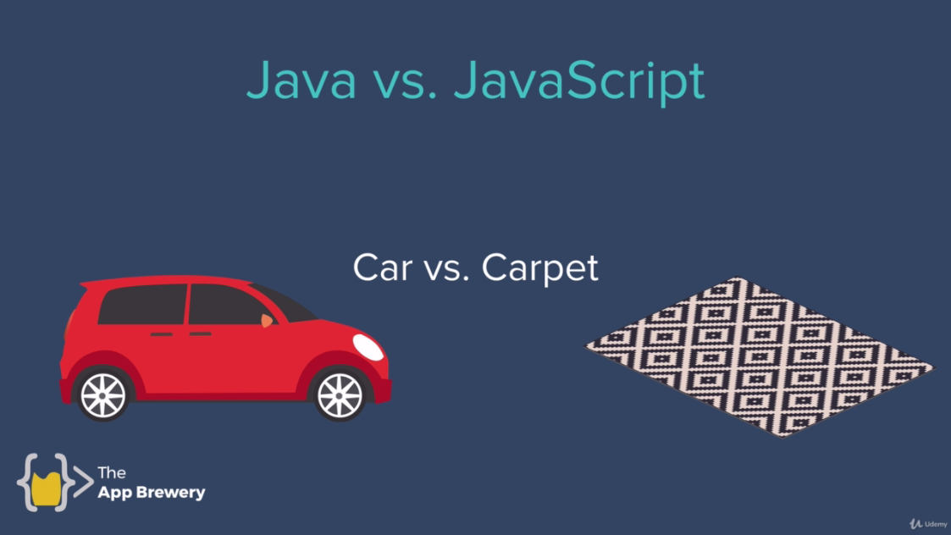



JS is interpreted programming language and java is compiled programming language.

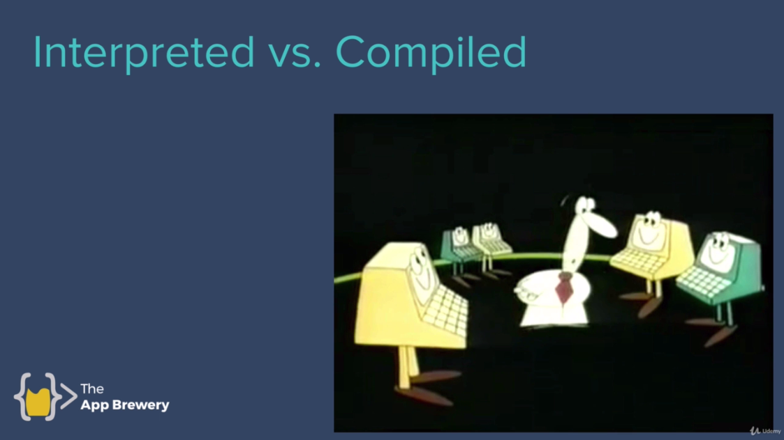

Link

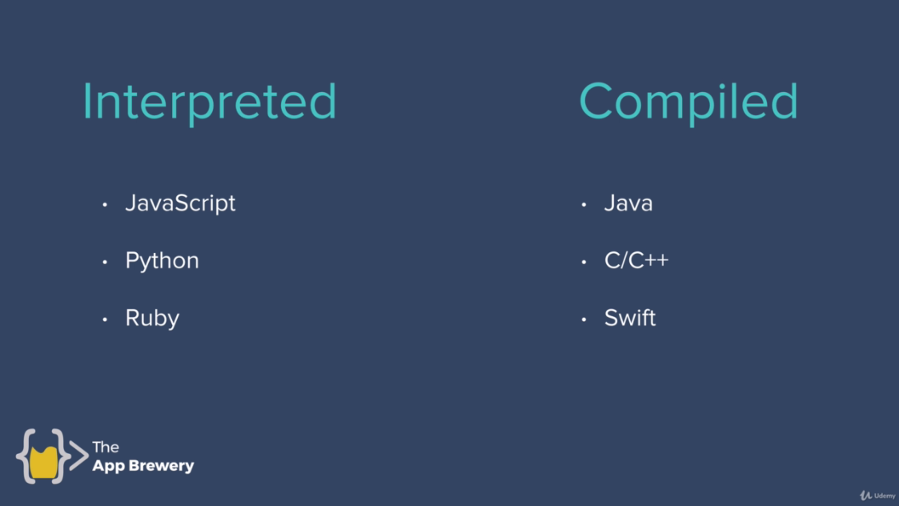

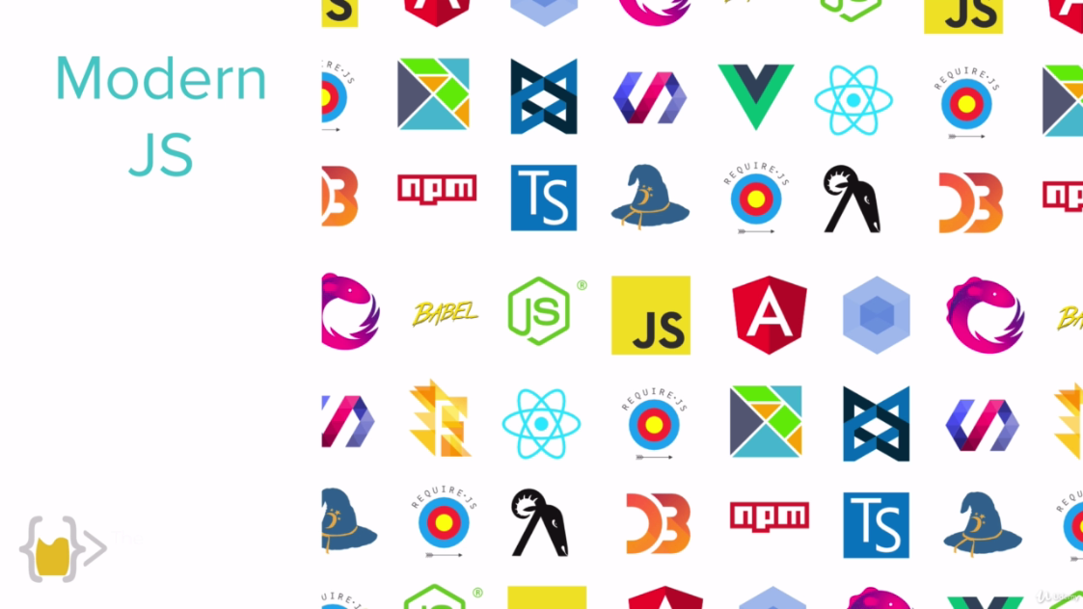

JS supported browsers list is given below:



2018 popularity contest

JS is on top.

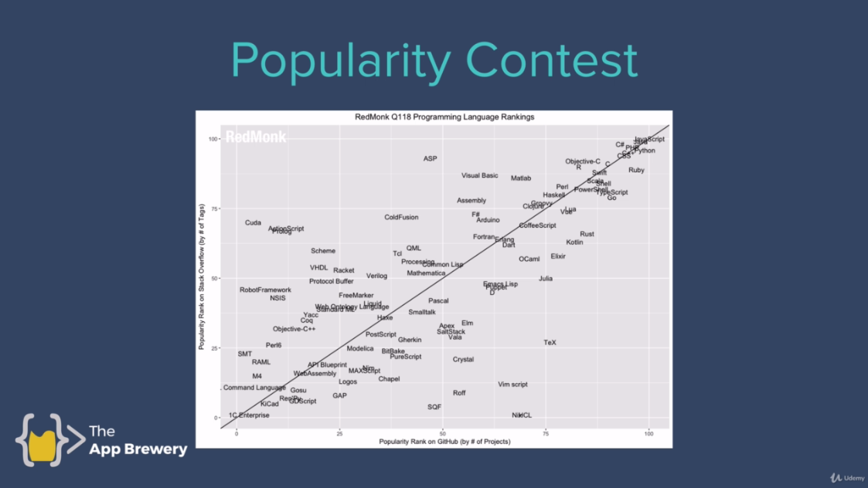

Languages need to learn first by desires.

|  |  |
| --- | --- |
| Name | Use |
| Swift | IOS App |
| Java | Android |
| JavaScript | Web and web-sites |